SENTIMENT ANALYSIS OF TRIPADVISOR REVIEWS USING LSTM DEEP NEURAL NETWORKS ADDING DENSE LAYERS OF RELU AND SOFTMAX ACTIVATION FUNCTIONS WITH INPUT SIZE 1000

Bf.head()



BIGRAMS:

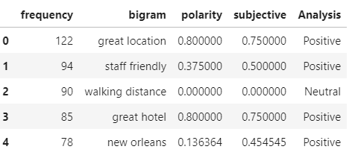

Word embeddings



Emmdedding layer:

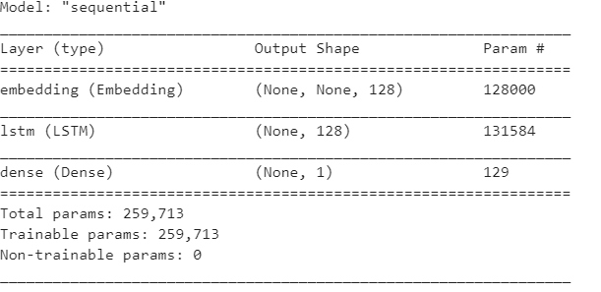

One hot and label encoder

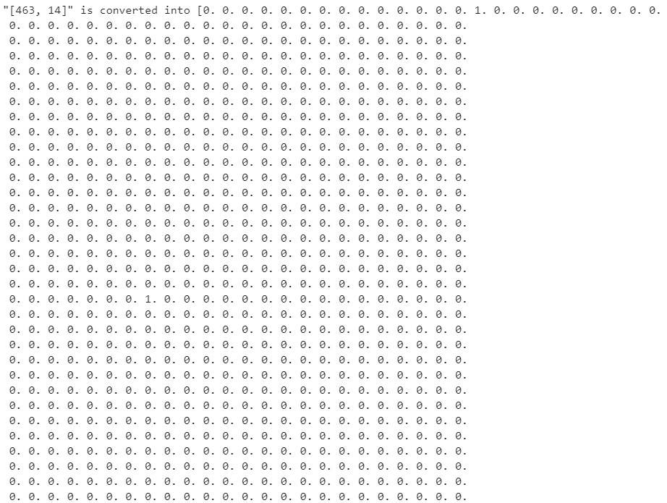



TRAINING AND VALIDATION ACCURACY:

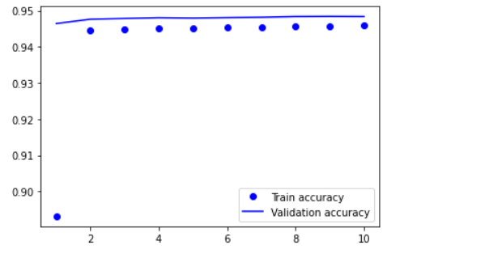

TEST ACCURACY:

